Building At Mahim.

1. Project Information
- Project Name: The Bella Vista
- Location:Mahim.
- Plot Area: __________________
- Built-up Area: __________________
- Project Type: High-rise residential and commercial development
- Client/Developer: Transindia Group
- Status: __________________
- Completion Year: __________________

2. Project Overview
The Bella Vista is a contemporary high-rise development comprising residential towers with commercial spaces at street level. The project combines efficient tower planning with a distinctive façade, landscaped terraces and rooftop recreation. Its clean architectural character creates a prominent urban identity.

3. Building Features
- Multiple high-rise residential wings
- Ground-floor commercial frontage
- Stilt-level parking
- Curved corner balconies with extensive glazing
- Strong vertical façade fins and framed windows
- Landscaped balcony bands
- Defined pedestrian and vehicular entrances
- Rooftop jogging track
- Children’s play area
- Landscaped seating and relaxation zones
- Pergolas and outdoor gathering spaces
- Recreational lawn and activity areas
- Integrated façade and terrace lighting

4. Design Concept
The design combines strong vertical lines with softened curved corners to create a modern and elegant tower composition. A restrained white and grey palette is enhanced through glazing, dark accents and integrated greenery. Rooftop amenities transform the upper level into an active recreational landscape for residents.
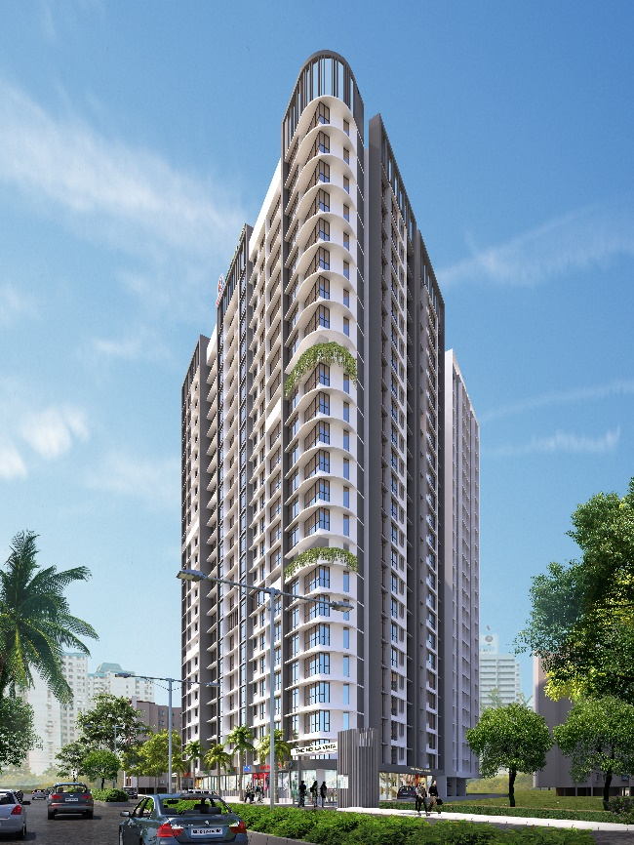
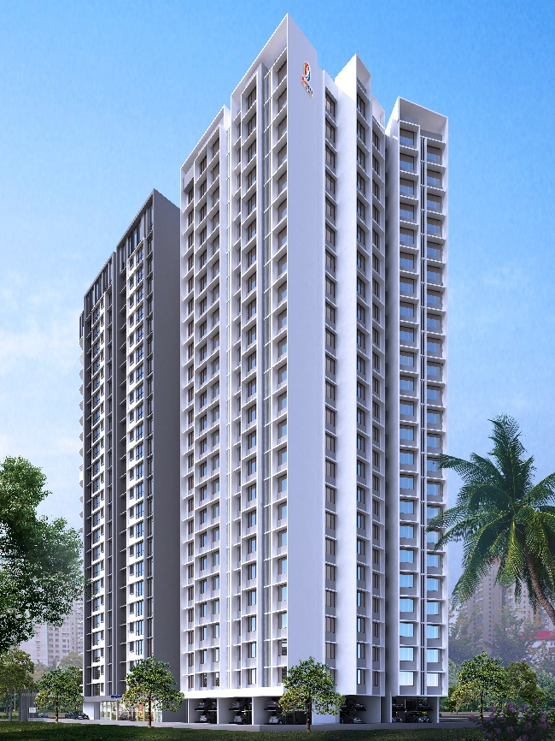
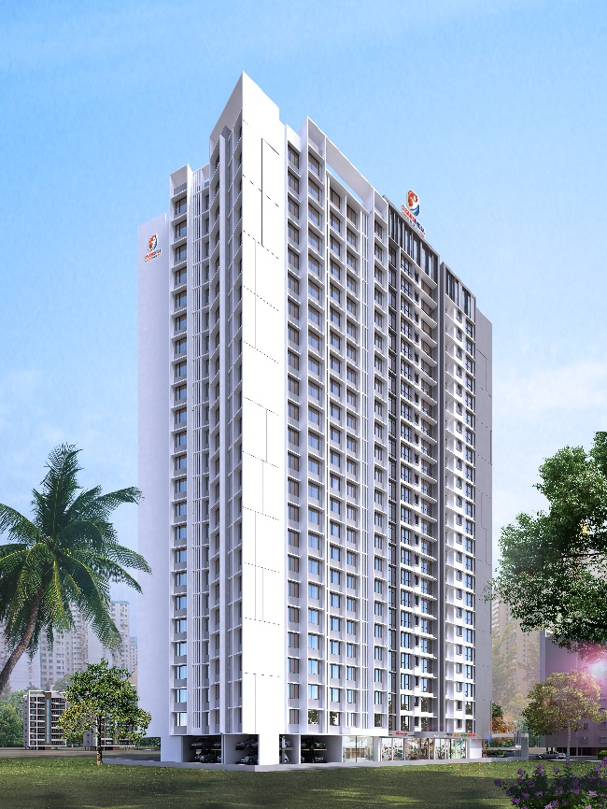
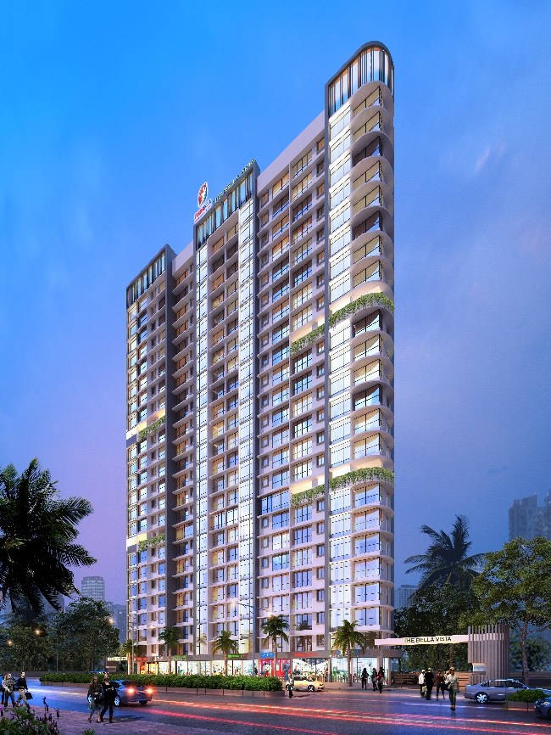
Image 1.
Image 2.
Image 4.
Image 3.
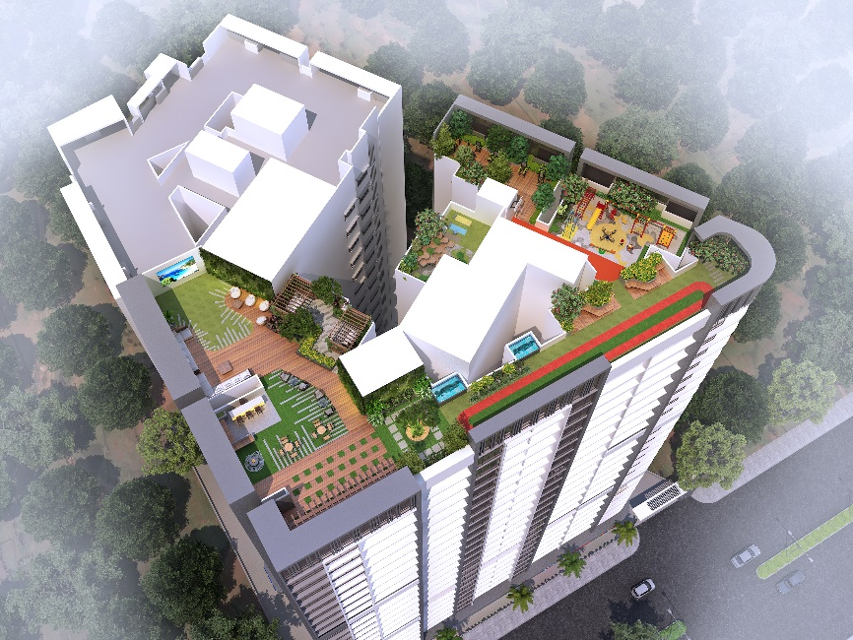
Image 5
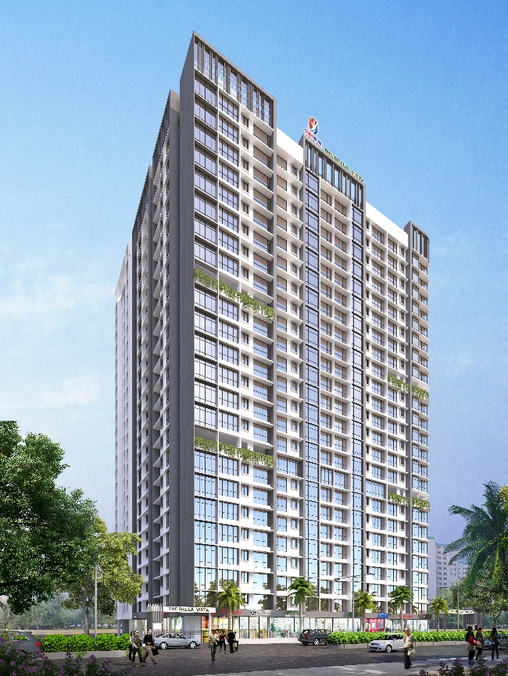
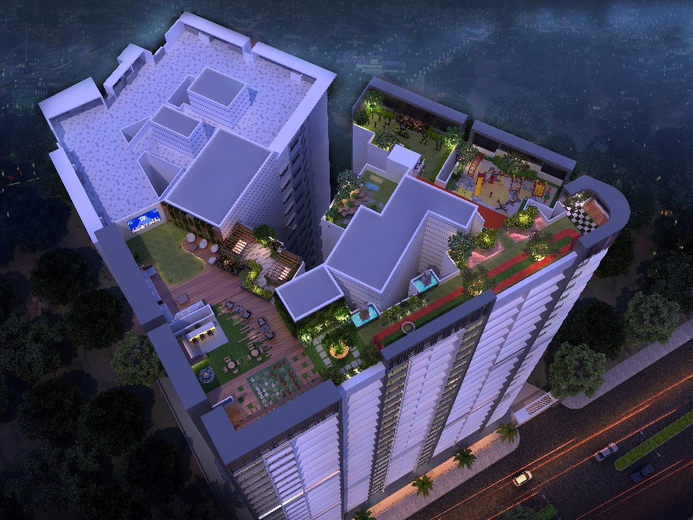
Image 7.
Image 6.

